Hi everyone,

XUNO Family App User Guide

XUNO Family is an app that will help make communication with the school quick and easy - giving you access to a wealth of information, without having to sit at a computer.
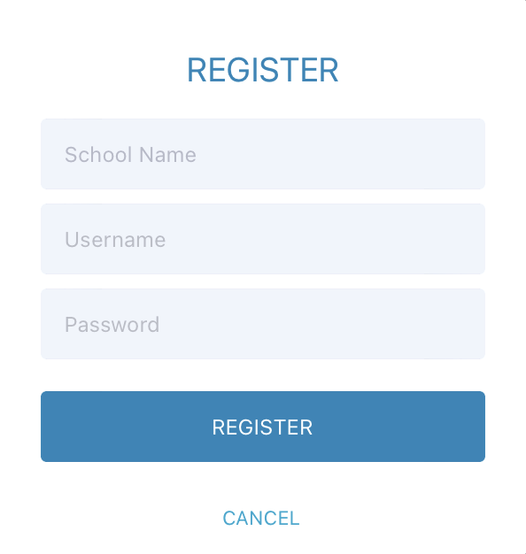

To log in, follow these steps:

- Download XUNO Family from the App store (iOS) or Play store (Android)
- Open the app
- If asked, please allow push notiﬁcations for the most
convenient experience with the app
- Search for your school by typing the ﬁrst few letters and
then selecting your school from the list that appears.

If you have forgotten your password or Username, you’ll need to head to your school’s Xuno website to reset it.
Go to: https://corryongc.xuno.com.au

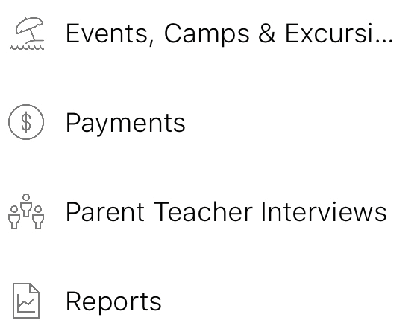
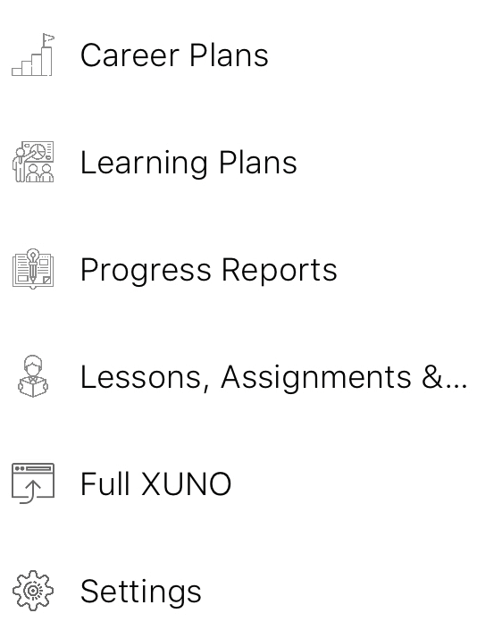
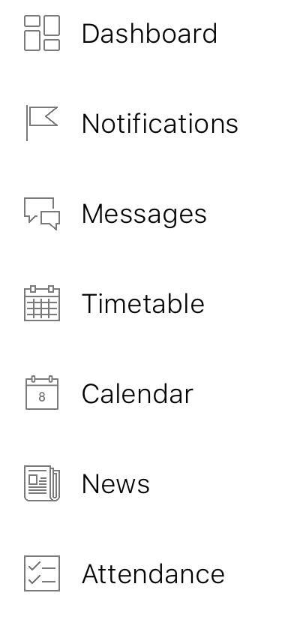
XUNO Family
Features: At a glance

A collection of widgets including Upcoming Payments, Attendance, Events, Forms and Homework
A list of all notiﬁcations you’ve received since registering
your account on the XUNO Family app
Send a new message or read messages sent to you by
school staﬀ
Your child’s timetable, showing today’s date by default
and any relevant timetable changes
A list of upcoming events and important dates

School newsletters, announcements and other important information
View your child’s marked attendance and contact the
school regarding future or past absences
View, approve, ﬁll out forms and make online payments
for Excursions, Camps and Events

Pay for Events, Fees, Voluntary Contributions and other items
Book Parent Teacher interviews and manage existing bookings
View and print your child’s school reports,
including reports from past years

View published Career Plans. Edit / contribute to career plans (Students only)
View published Career Plans. Edit / contribute to career plans (Students only)
View published Progress Reports and feedback

View homework and class learning tasks, submit assignments, view learning task results if published Log into the full XUNO website if necessary with one
single click - No need to re-enter your password
Check your app settings, and if necessary, send a report to the support team in a few simple taps

To send a new message to a staﬀ member
- Tap the menu button in the top left
- Tap Messages
- Tap the name of a Staﬀ member who you’ve messaged in the past to view Message history
or reply to a previous message
- To start a new conversation, tap the + button in the top right and select from your child’s teachers and coordinators
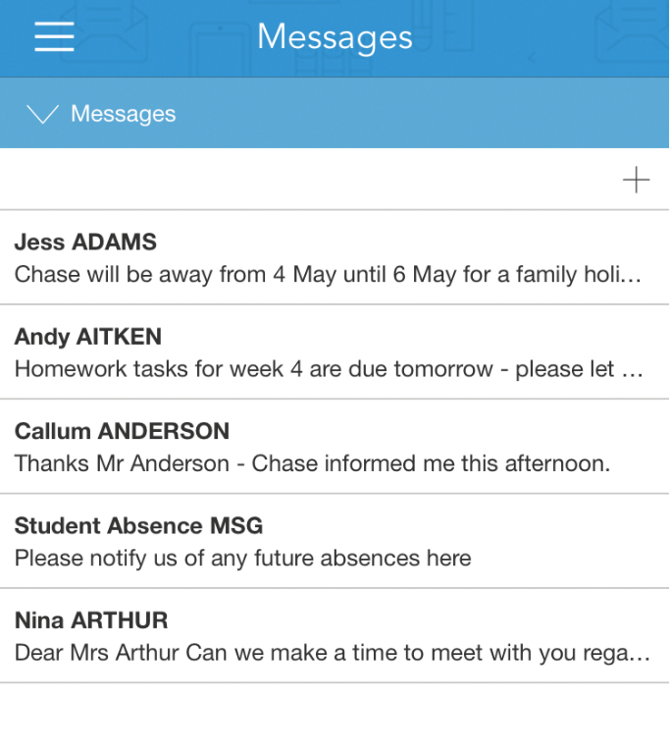
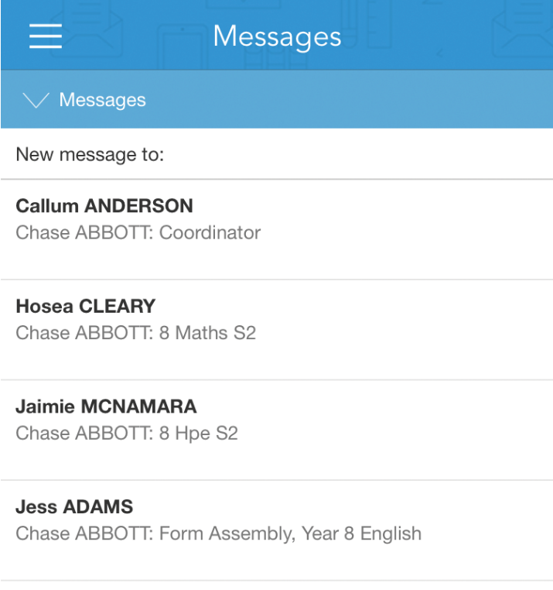

Please note: Schools may choose to disable certain XUNO features at their discretion - if you don’t see some of the menu items contained within this user guide, it may mean that the school has chosen not to enable it. If you are interested in using a particular feature, or can’t see a menu item that you’ve been asked to use by the school, please contact the school directly to discuss your options.

